JOUR 4251 Advertising and behavior - Ch. 6, part 1
Theory of Planned Behavior Attitude
Norms
Perceived
behavioral
control
Intention Behavior
Theory of Planned Behavior
Behavioral beliefs
Normative
beliefs
Efficacy beliefs
Attitude
Norms
Perceived behavioral control
Intention Behavior
Beliefs
Behavior: Social distancing
Behavioral beliefs - beliefs about the outcome
Positive: “Social distancing will reduce spreading of the virus” Negative: “I’m not in a risk group, thus, I will not get sick” Normative beliefs - beliefs about what others might think Positive: “I believe that my parents want me to do this” Negative: “Everyone around me think it is okay to still meet up” Efficacy beliefs - beliefs about whether people think they can do it Positive: “I can stay inside most of the time anyway” Negative: “I don’t know how long 6 feet is”
Theory of Planned Behavior
Behavioral beliefs
Normative
beliefs
Efficacy beliefs
Attitude
Norms
Perceived behavioral control
Intention Behavior
Implications for advertising
1. Determine WHAT behavior you want to influence
2. Determine target group (WHO)
3. Research whether it is attitudes, subjective norms or perceived behavioral control that matters in purchasing (if purchasing is the goal)
4. Identify the specific beliefs that influence the purchasing decision
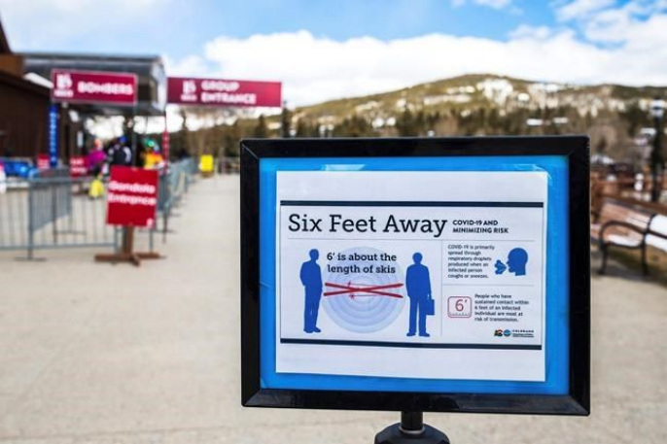
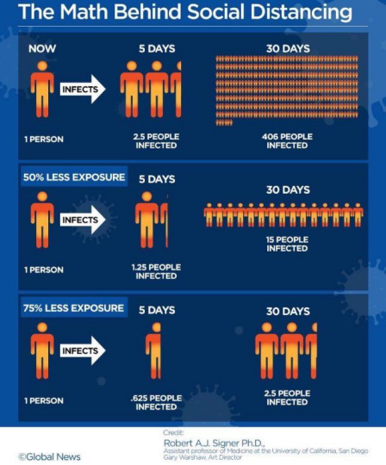
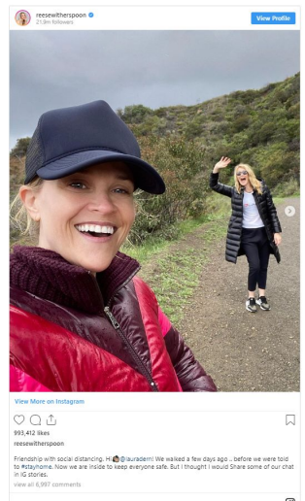
Think like an advertiser!
● Select a product
● Describe your target audience
● List what you think may be attitudes, subjective norms, and perceived behavioral control that would influence the behavioral intentions to purchase the item
● Create a campaign idea to address one of these factors that you think may be important
What’s next?
● Continue reading Chapter 6
○ Submit reading response #7 by Thursday, March 26 ● No class this Thursday
● Assignment #4 on behavior is due by April 23

